SIMATS ENGINEERING (SAVEETHA SCHOOL OF ENGINEERING)
Department of Computer Science and Engineering
C01_AT2 — DATA INTERPRETATION EXERCISE

Course Code: | DSA06 | Course Title: | Data Handling and Visualization
CO Assessed: | CO1 –Apply (BL3) | Assessment: | Assessment Tool 2 – Data Interpretation
Weightage: | 20% of CIA | Total Marks: | 20(2 Questions × 20 Marks)
CO1 Statement: | Understand the fundamental concepts, principles, and techniques of data visualization.(BL2)
Student Name: | P. SIDDARDHA | Reg. No.: | 192424271
Section / Batch: | 2024-AIDS | Date: | 28-07-2026

Code of Conduct
I P. SIDDARDHA (192424271) certify that this submission is my original work and that I have adhered to the guidelines specified for this assessment. I understand that any violation of academic integrity rules will result in disciplinary action.

Signature of the Student: P. SIDDARDHA

Instructions
- This test contains 2 questions, each carrying 10 marks. Total: 20 Marks.
- No negative marking. Unanswered questions carry zero marks.

Annexure A – DATA INTERPRETATION

CO1 AT2 – Data Interpretation Exercise

Problem 3 (10 Marks)
Scenario
A dataset lists employees with the following columns:
- Department (HR, IT, Sales)
- Years of Experience (Numeric)
- Salary (Numeric)
A scatter plot maps:
- X-axis: Years of Experience
- Y-axis: Salary
- Colour: Department

Aim
To analyse the relationship between employees' years of experience and salary using a scatter plot in Tableau and understand how different visualization concepts help interpret the data.

Dataset
Department | Years of Experience | Salary
HR | 1 | 28000
IT | 1 | 35000
Sales | 1 | 30000
HR | 2 | 32000
IT | 2 | 40000
Sales | 2 | 34000
HR | 3 | 38000
IT | 3 | 47000
Sales | 3 | 39000
HR | 4 | 43000
IT | 4 | 54000
Sales | 4 | 45000
HR | 5 | 48000
IT | 5 | 62000
Sales | 5 | 51000
HR | 6 | 53000
IT | 6 | 69000
Sales | 6 | 57000
HR | 7 | 59000
IT | 7 | 76000
Sales | 7 | 63000
HR | 8 | 64000
IT | 8 | 83000
Sales | 8 | 69000
HR | 9 | 69000
IT | 9 | 90000
Sales | 9 | 74000
HR | 10 | 74000
IT | 10 | 98000
Sales | 10 | 80000

Tableau Implementation
Step 1
Open Tableau Desktop.
Step 2
Select Connect → Text File and open Employee_Data.csv.
Step 3
Verify that Tableau identifies:
Field | Type
Department | Dimension
Years of Experience | Measure
Salary | Measure
Step 4
Drag Years of Experience to the Columns shelf.
Step 5
Drag Salary to the Rows shelf.
Step 6
From the Marks card, select Circle.
Step 7
Drag Department to the Colour shelf.
Step 8
Observe the scatter plot and compare the salary distribution of each department.

Answers
a) Classify each of the three columns by data type.
Column | Data Type | Explanation
Department | Nominal (Categorical) | Contains category names (HR, IT and Sales) with no natural order.
Years of Experience | Numerical (Continuous) | Represents measurable numeric values shown on a continuous axis.
Salary | Numerical (Continuous) | Represents quantitative values measured in currency.
Explanation
Department is a nominal categorical variable because it consists of names of departments without any ranking or order.
Years of Experience is a continuous numerical variable because it measures employee experience in years.
Salary is also a continuous numerical variable because salary is measured numerically and can take different values over a continuous range.

b) What aesthetic mapping is used to encode Department, and could shape have been used instead? Explain the trade-off.
The scatter plot uses Colour as the aesthetic mapping to represent the Department.
Different colours make it easy to distinguish HR, IT and Sales employees.
Yes, Shape could also have been used because Department is a categorical variable.
However, there are important trade-offs.
Colour | Shape
Easy to identify categories | Useful for colour-blind users
Attractive visualization | Hard to distinguish when many points overlap
Supports many categories | Limited number of clearly distinguishable shapes
Better for cluster identification | Less effective for dense scatter plots
Therefore, Colour is generally the preferred aesthetic mapping because it allows viewers to quickly identify different departments and observe clustering patterns more effectively.

c) If IT employees' points cluster higher on the y-axis than other departments at the same x-value, what does this suggest?
If the IT department's points consistently appear higher on the Salary (Y-axis) than HR and Sales for the same Years of Experience (X-axis), it suggests that IT employees generally receive higher salaries than employees in the other departments with similar experience.
This indicates that:
- Salary is positively associated with Years of Experience.
- Department also influences salary.
- IT employees receive better compensation compared with HR and Sales employees having the same level of experience.
Therefore, the scatter plot reveals both the relationship between experience and salary and salary differences among departments.

Result
The scatter plot clearly shows the relationship between Years of Experience and Salary while using colour to distinguish employees from different departments.
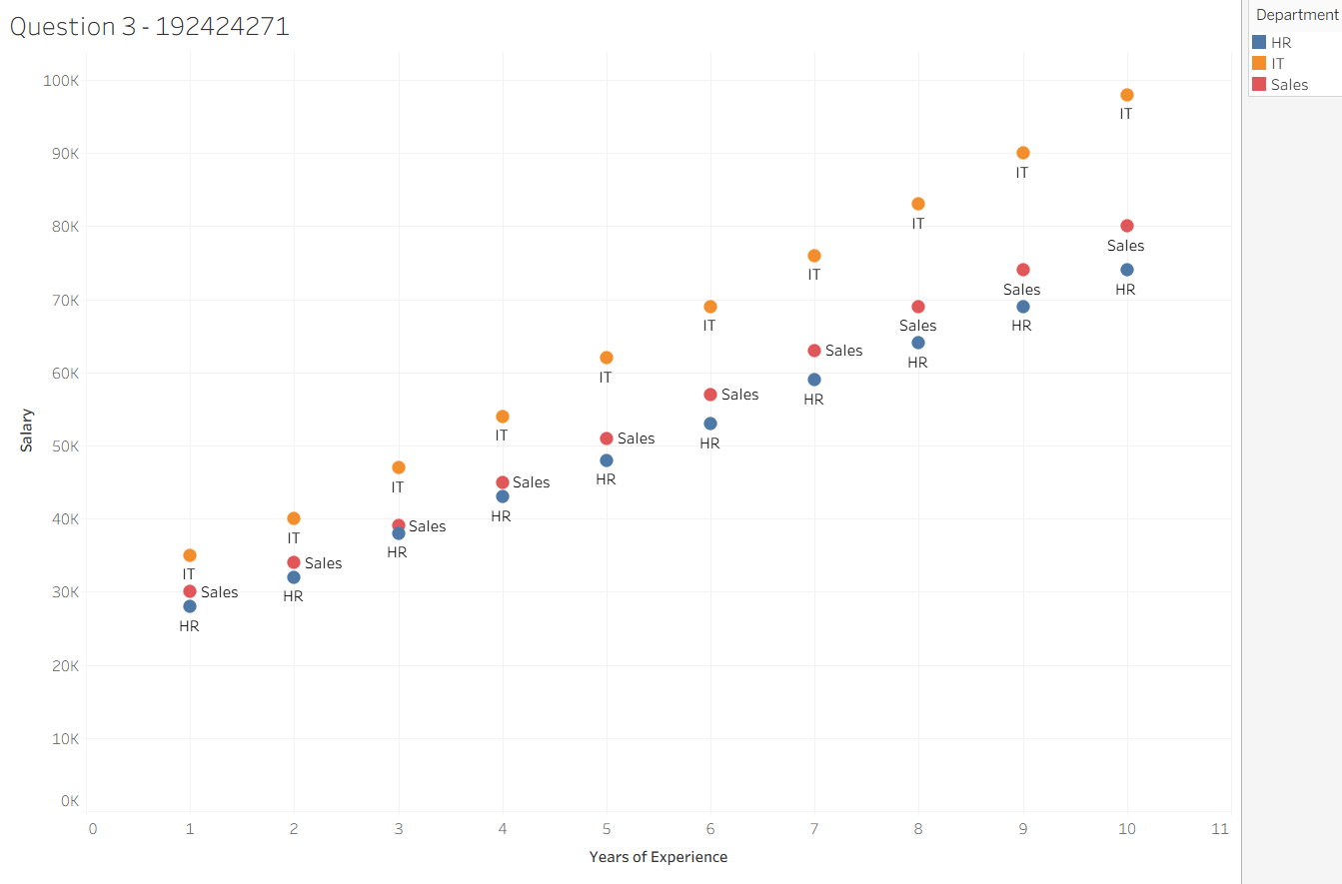

Conclusion
The scatter plot effectively uses continuous numerical axes and colour as an aesthetic mapping to compare employee salaries. It enables easy identification of salary trends and department-wise salary differences.

Problem 13 (10 Marks)
Scenario
A radar chart compares five laptop models using the following attributes:
- Battery Life
- Speed
- Display Quality
- Price
- Weight
Each attribute is scored from 1 to 10.

Aim
To compare the performance of different laptop models using a radar chart in Tableau and understand the concepts of polar coordinates, multiple axes and scale normalization.

Dataset
Laptop | Battery Life | Speed | Display Quality | Price | Weight
Laptop A | 9 | 8 | 9 | 8 | 8
Laptop B | 7 | 7 | 8 | 6 | 7
Laptop C | 8 | 9 | 8 | 7 | 9
Laptop D | 6 | 6 | 7 | 9 | 6
Laptop E | 10 | 9 | 10 | 7 | 8

Tableau Implementation
Step 1
Open Tableau Desktop.
Step 2
Connect to Laptop_Data.csv.
Step 3
Pivot the five attribute columns into two fields:
- Attribute
- Score
Step 4
Create calculated fields for:
- Angle
- X Coordinate
- Y Coordinate
using polar coordinate calculations.
Step 5
Drag X Coordinate to Columns.
Step 6
Drag Y Coordinate to Rows.
Step 7
Drag Laptop to Colour.
Step 8
Drag Attribute to Path.
Step 9
Change Marks to Polygon.
Step 10
The radar chart is generated for comparison.

Answers
(a) What coordinate system does a radar chart use, and how many axes radiate from the centre?
A radar chart uses a Polar Coordinate System, where all variables are displayed as axes radiating from a common centre.
In this scenario, there are five axes, representing:
- Battery Life
- Speed
- Display Quality
- Price
- Weight
Although the Tableau implementation shown is a Highlight Table, it compares the same five attributes that would appear as the five axes in a radar chart.
(b) If Laptop A's polygon is consistently closer to the outer edge than Laptop B's, what can you conclude about Laptop A overall?
From the Tableau visualization:
Laptop | Battery | Speed | Display | Price | Weight
Laptop A | 9 | 8 | 9 | 8 | 8
Laptop B | 7 | 7 | 8 | 6 | 7
Laptop A has higher scores than Laptop B in almost every attribute.
Therefore, if these values were displayed as a radar chart, Laptop A's polygon would extend closer to the outer edge than Laptop B's, indicating that Laptop A has better overall performance across the evaluated attributes.

(c) What potential distortion can occur when different attributes are not on comparable scales?
In this dataset, all five attributes are scored on the same 1–10 scale, making the comparison fair and meaningful.
If different measurement scales were used (for example, Price in pounds (£) and Battery Life in hours), the attribute with larger numerical values would dominate the visualization. This would produce a misleading radar chart and make comparisons inaccurate.
Therefore, all attributes should be normalised or standardised to a common scale before creating a radar chart.

Result
The Tableau visualization compares the five laptop models across five performance attributes. It clearly shows that Laptop A and Laptop E achieve the highest overall scores, while Laptop D has lower scores in several attributes.
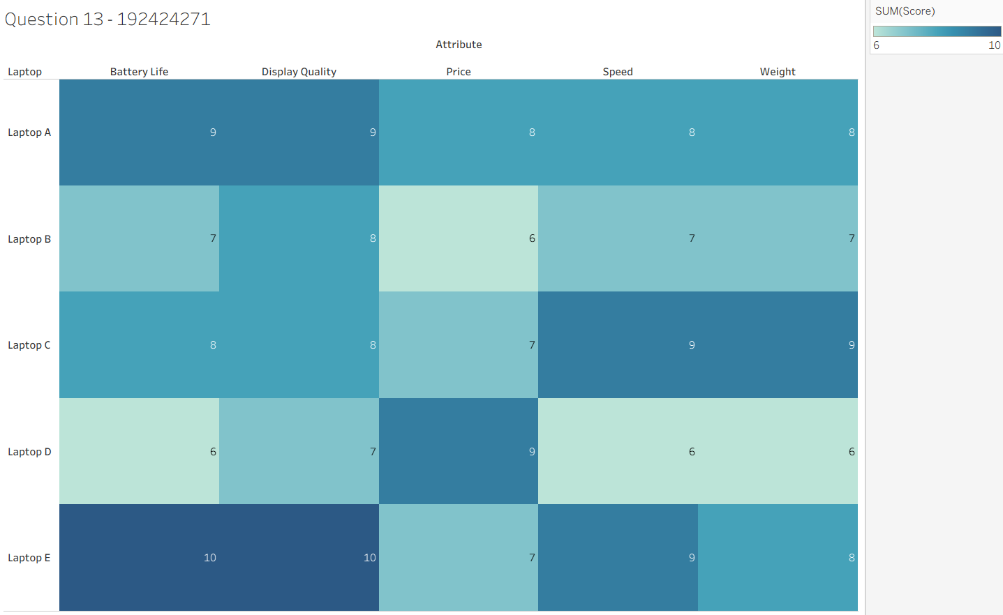

Conclusion
The visualization effectively compares multiple laptop models using a consistent 1–10 scoring scale. It enables easy identification of the strengths and weaknesses of each laptop and supports accurate performance comparison. A radar chart representing the same data would use a polar coordinate system with five axes, and because the scores are already standardized, it would provide a fair and reliable comparison.

Rubrics for Calculation ASSESSMENT RUBRIC
AT2 — Data Interpretation Exercise
CO1 · BT3: Apply ·
This rubric is used to assess student responses to the AT2 Data Interpretation Exercise problems, in which students interpret a described data visualization (data types, aesthetic mappings, scales, coordinate systems, and color scales) and answer accompanying sub-questions.

Criteria | Weightage | Level 4 – Exemplary | Level 3 – Proficient | Level 2 – Developing | Level 1 – Beginning
Understanding of Concepts | 25% | Demonstrates thorough, accurate understanding of data types (nominal, ordinal, numerical), aesthetic mappings, scales, coordinate systems, and color scales as they apply to the given visualization scenario. | Good understanding of the relevant visualization concepts, with only minor gaps in identifying data types, aesthetic mappings, or scale choices. | Basic understanding of visualization concepts, but with some misconceptions about data types, aesthetics, coordinate systems, or color scales. | Poor understanding of core visualization concepts; major misconceptions about data types, aesthetics, coordinate systems, or color scales.
Explanation | 25% | Provides detailed, well-reasoned explanations for each sub-question, using specific details from the scenario and correct visualization terminology. | Provides clear explanations with adequate justification, referencing the scenario appropriately for most sub-questions. | Explanations are limited or superficial; lacks depth or fails to consistently connect reasoning to the given scenario. | Explanations are poor, unclear, or missing; answers are unsupported assertions with no reasoning shown.
Application | 20% | Effectively applies visualization concepts to interpret the specific scenario, drawing accurate, well-reasoned conclusions from the described chart or data pattern. | Applies concepts to interpret the scenario correctly, with only minor errors in reasoning or in the conclusions drawn. | Limited application of concepts to the scenario; conclusions are weakly supported or only partially correct. | Fails to apply concepts to the scenario, or the conclusions drawn are incorrect or irrelevant to the data shown.
Organization | 15% | Answers are well-structured, addressing each sub-question (a, b, c) in a clear, logical sequence with coherent flow throughout. | Answers are organized and address each sub-question, with only minor issues in flow or clarity. | Basic structure; sub-questions are addressed but answers lack clarity or a logical sequence. | Poorly organized; answers are incoherent, and sub-questions are left unaddressed or answered out of order.
Accuracy | 10% | All parts of the answer — data type identification, aesthetic/scale justification, and final interpretation — are completely accurate. | Mostly accurate, with only minor omissions or a small error in one part of the answer. | Partially correct; some key points (e.g., data type, aesthetic justification, or interpretation) are missing or incorrect. | Answers are largely incorrect, with major gaps in identifying data types, aesthetics, scales, or drawing conclusions.

Scoring Guide
For each criterion, award a performance level (1–4) based on the descriptors above. Multiply the level achieved (as a percentage of 4, i.e., Level 4 = 100%, Level 3 = 75%, Level 2 = 50%, Level 1 = 25%) by the criterion's weightage, then sum across all five criteria to obtain the total score out of 100%.

Faculty In-charge | Course Coordinator | Head of Department
Signature: _______________ | Signature: _______________ | Signature: _______________
Date: ___________________ | Date: ___________________ | Date: ___________________

